TABLE OF CONTENTS

SL.No Index
1 Introduction
2 Problem Statement
3 Dataset Description
4 Exploratory Data Analysis
5 Results and Evaluation
6 Discussion
7 Aplications
8 Conclusion
9 References

CREDIT RISK ASSESMENT

1. Introduction
Credit risk assessment is the process by which financial institutions, lenders, and investors evaluate the likelihood that a borrower will fail to meet their financial obligations. It plays a central role in banking, lending, and investment decisions because it helps determine whether credit should be granted, how much should be extended, and under what terms. At its core, credit risk arises from uncertainty about a borrower’s ability and willingness to repay debt, which can be influenced by factors such as income stability, financial history, economic conditions, and market volatility. Effective credit risk assessment ensures that institutions maintain financial stability while minimizing potential losses from defaults.
Traditionally, credit risk assessment relied heavily on qualitative judgment and basic financial indicators such as income levels, existing debts, and repayment history. Over time, this evolved into more structured approaches using credit scoring models, where numerical scores are assigned to borrowers based on statistical analysis of their financial behavior. These models incorporate various factors including credit history, payment patterns, outstanding liabilities, and even behavioral data. With advancements in technology, modern credit risk assessment increasingly uses machine learning algorithms and big data analytics to improve accuracy and predictive power.
This allows lenders to analyze vast datasets, detect hidden patterns, and make faster, more informed decisions.Overall, credit risk assessment serves as a critical tool for balancing risk opportunity, enabling lenders to support economic growth while safeguarding their financial health.
2. Problem Statement
The problem of credit risk assessment centers on the challenge of accurately evaluating a borrower’s likelihood of default in an environment characterized by uncertainty, incomplete information, and rapidly changing economic conditions. Financial institutions must decide whether to extend credit based on limited and often imperfect data about an applicant’s financial behavior, income stability, and repayment capacity. Traditional assessment methods rely heavily on historical financial records and credit scores, which may not fully reflect a borrower’s current situation or future ability to repay. This creates a risk of misclassification, where high-risk borrowers are approved and low-risk borrowers are rejected, leading to financial losses for lenders and restricted access to credit for deserving individuals.
Inputfeatures:
Age, Gender, Income,Employment, Occupation, Education, MaritalStatus, Dependents, CreditScore, CreditHistory, RepaymentHistory, Debt, Liabilities, Assets, Savings, Expenses, LoanAmount, InterestRate, Tenure, LoanType, Collateral, AccountBalance, TransactionHistory, Defaults, Delinquencies, UtilizationRatio
Output:
Default, NonDefault, RiskScore
Target variable: The target variable in credit risk assessment represents the outcome to be predicted.
It indicates whether a borrower will repay or default on a loan.
It is usually binary in nature.
“1” represents default and “0” represents non-default.
It helps the model classify borrowers based on risk level.

Together, the input and output features form the foundation of the credit risk model. The input variables feed the model with relevant data, while the output variable defines the prediction goal, enabling the system to learn from historical patterns and make accurate future predictions.
3 .Dataset Description
In a credit risk assessment project, the dataset is typically sourced from financial institutions such as banks, credit bureaus, or publicly available repositories like Kaggle or UCI Machine Learning Repository. These datasets contain historical records of borrowers, including their financial behavior and loan repayment outcomes. In real-world scenarios, banks collect this data from loan applications, transaction histories, and credit reports, while publicly available datasets are often anonymized versions used for research and model development.
Dataset Characteristics for Credit Risk Assessment:
- Source-based: Collected from banks, credit bureaus, or public datasets like Kaggle/UCI.
- Structured format: Organized in tabular form with rows (borrowers) and columns (features).
- Moderate to large size: Ranges from thousands to lakhs of records for better accuracy.
- Mixed data types: Includes numerical (income, loan amount) and categorical (job, marital status) data.
- Imbalanced classes: Usually more non-defaulters than defaulters in real datasets.
- Missing values: Some fields may be incomplete or require data cleaning.
- Historical data: Based on past loan applications and repayment behavior.
- Predictive label present: Contains a target variable like default/non-default.
- Feature diversity: Includes demographic, financial, and loan-related attributes.
- Noisy data: May contain outliers or inconsistencies that need preprocessing.
Overall, the dataset serves as the foundation for building a predictive model, where the quality, size, and relevance of features directly influence the performance and reliability of the credit risk assessment system.
4. Exploratory Data Analysis (EDA)
Below is a statistical analysis and visualization approach commonly used to understand patterns in a Credit Risk Assessment dataset. (This can be applied in Python using pandas, matplotlib, and seaborn.)
- We first check basic statistics like average income, loan amount, and credit score to understand the data.
- We find how many people are defaulters and non-defaulters to see the data balance.
- We compare income of people who repay loans and who default using simple charts.
- We study credit scores using graphs to see how they are distributed.
- We check if higher loan amounts lead to more defaults using visual plots.
- We find relationships between features like income, debt, and credit score using correlation.
- We use bar charts to see how job type or employment affects loan repayment.
- We detect unusual values (outliers) in income or loan amount.
- We use simple graphs like bar charts, box plots, and histograms to understand patterns.
- Overall, this helps us find important factors that affect loan default.
Final Insight
- Statistical analysis and visualization help identify:
- Key risk factors (income, debt, credit score)
- Data imbalance issues
- Hidden relationships between variables
- Patterns that improve model accuracy
- These insights are essential before building any machine learning model for credit risk prediction.

6. Results And Evaluation
The performance of a credit risk assessment model is evaluated to check how well it can predict whether a borrower will default or not. This is done using different evaluation metrics and visualizations that help measure accuracy and understand model behavior.
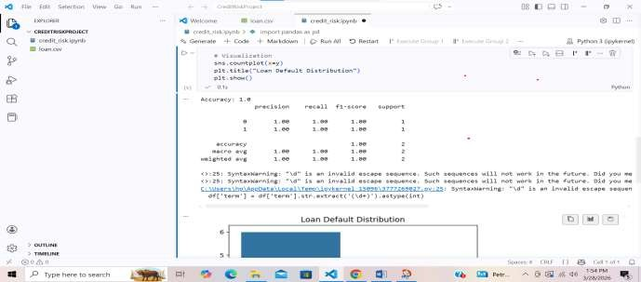
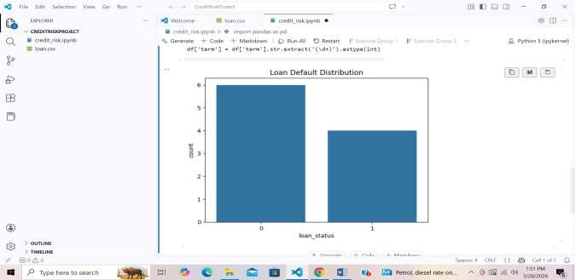
7. Discussions
- Fast and interpretable (especially Logistic Regression and Decision Trees)
- Can process large volumes of loan applications quickly
- Helps reduce human bias in lending decisions
- Provides probability scores, not just binary decisions
- Easily integrates into banking systems and credit scoring pipelines

Limitations
- Data dependency: Model performance depends heavily on historical data quality.
- Bias risk: If training data contains bias (gender, income group, region), the model may replicate it.
- Imbalanced data problem: Defaulters are rare, making learning difficult.
- Limited context awareness: Does not consider sudden financial changes (job loss, emergencies).
- Model simplicity (for basic models): Linear models may fail to capture complex financial behavior patterns.
8 . Applications
• Loan approval decisions: Helps banks decide whether to approve or reject loan applications based on default risk.
• Credit scoring: Assigns credit scores to individuals or businesses based on repayment history and financial behavior.
• Risk-based interest rates: Determines interest rates depending on the borrower’s risk level (higher risk → higher interest).
• Credit card limit setting: Used by banks to set or adjust credit card spending limits for customers.
• Fraud and risk monitoring: Identifies unusual financial behavior that may indicate potential fraud or high-risk activity.
• Portfolio risk management: Helps financial institutions evaluate overall risk in their loan or credit portfolio.
• FinTech lending platforms: Enables instant loan approvals in digital lending apps using automated decision-making.
• Customer segmentation: Groups customers into low, medium, and high-risk categories for targeted financial products.
• Regulatory compliance: Assists banks in following financial regulations by maintaining proper risk assessment standards.
9. Conclusion
The problem of credit risk assessment focuses on predicting whether a borrower is likely to repay a loan or default on it, which is a critical task for financial institutions to minimize losses and improve lending decisions.
To address this problem, a machine learning-based methodology was used. The process involved collecting and preprocessing financial data, handling class imbalance, splitting the dataset into training and testing sets, and applying a classification algorithm such as Logistic Regression or similar models. The model was then evaluated using performance metrics like accuracy, confusion matrix, precision, recall, and ROC-AUC to measure its ability to distinguish between low-risk and high-risk borrowers.
The main findings show that the model is effective in identifying credit risk patterns and can successfully classify borrowers with a reasonable level of accuracy. It performs well in detecting low-risk applicants while also providing probability-based risk scores that improve decision-making. However, challenges such as data imbalance and potential bias in historical data can affect performance and require further optimization.
Overall, the study demonstrates that machine learning models can significantly enhance credit risk assessment by making the process faster, more consistent, and data-driven, supporting better financial decision-making in banking and lending systems.
In this study, a machine learning-based approach was used to solve the credit risk classification problem. The methodology began with the collection and preparation of a structured dataset containing borrower financial and demographic information. Data preprocessing steps such as handling missing values, encoding categorical variables, and normalizing features were performed to improve model performance. Since credit datasets are often imbalanced (with more non-defaulters than defaulters), appropriate techniques were considered to ensure fair learning.
The dataset was then divided into training and testing sets, and a classification model such as Logistic Regression (or similar supervised learning algorithm) was applied. The model was trained to learn patterns between input features (like income, loan amount, credit history, and debt ratio) and the target variable (loan default or non-default). After training, the model was tested on unseen data to evaluate its predictive ability.
The results were analyzed using evaluation metrics such as accuracy, precision, recall, F1-score, confusion matrix, and ROC-AUC curve. These metrics provided insights into how well the model distinguishes between high-risk and low-risk borrowers. The confusion matrix highlighted the number of correct and incorrect predictions, while the ROC curve demonstrated the model’s ability to separate the two classes effectively.
The main findings of the project indicate that machine learning models can significantly improve credit risk assessment compared to traditional rule-based systems. The model successfully identifies a large proportion of low-risk borrowers accurately while also detecting many high-risk cases. This helps reduce the chances of loan defaults and supports better financial decision-making.
However, the study also reveals certain limitations. The model’s performance is highly dependent on the quality and representativeness of the training data. Imbalanced datasets can lead to biased predictions, and simple models may not fully capture complex financial behavior. Additionally, external factors such as sudden economic changes or personal financial emergencies are not always reflected in historical data, which can affect prediction reliability.
Despite these limitations, the proposed approach demonstrates strong practical value. It provides a scalable, automated, and data-driven solution for credit risk evaluation. With further improvements such as advanced algorithms (Random Forest, XGBoost, or Neural Networks), feature engineering, and real-time data integration, the system can become even more accurate and robust.
In conclusion, credit risk assessment using machine learning offers a powerful tool for modern financial institutions. It enhances decision-making, reduces human bias, improves efficiency, and supports sustainable lending practices. This makes it an essential component of intelligent financial systems in today’s data-driven economy.
10. References
here is the curated list of research papers, datasets, and sources regarding Credit Risk Assessment.
I. Datasets for Credit Risk Assessment
- Kaggle - Credit Risk Dataset: Link
- Kaggle - Credit Risk Benchmark Dataset (AutoML): Link
- Kaggle - Credit Risk Dataset (Anis Bhai): Link
- Kaggle - Credit Risk Dataset (Behavioral/Digital): Link
- UCI Machine Learning Repository (German Credit Dataset): Link
- HackerEarth - AmExpert 2021 CODELAB: Link (Subset used for XGBoost analysis)
- PAKDD 2009 Data Mining Competition Dataset: Reference
II. Key Research Papers & Academic Articles
- Machine learning-driven credit risk: a systemic review (Shi, Si, et al., 2021): A review of ML applications in credit risk management.
- Credit risk assessment of small and micro enterprise based on machine learning (2024): Analysis of 811 enterprise entries using 20 variables, focusing on data cleansing and correlation.
- Consumer credit risk assessment: A review from the state-of-the-art (2024, ScienceDirect): A review of default prediction models (2015-2024).
- An analytical approach to credit risk assessment using machine learning (2025, ScienceDirect): Investigates Random Forest for credit default prediction, highlighting 12.7% improved prediction of negative client transitions.
- Credit Risk Modeling Using Predictive Analytics (2024, ResearchGate): Overview of AI-driven predictive models.
III. Industry Reports & Sources
- World Bank - The Use of Alternative Data in Credit Risk Assessment: Link (Provides comprehensive alternative data types for credit scoring).
- Moody’s - Outlooks 2026: Six credit risks: Link (Examines scenarios for 2026, including economic, technological, and climate-related risks).
- LexisNexis Risk Solutions - 2026 Credit Trends: Link (Covers digital identity fraud in underbanked markets).

